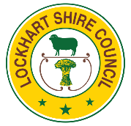
Lockhart Shire Council Event Application Kit

Kit 2
Small Event Application
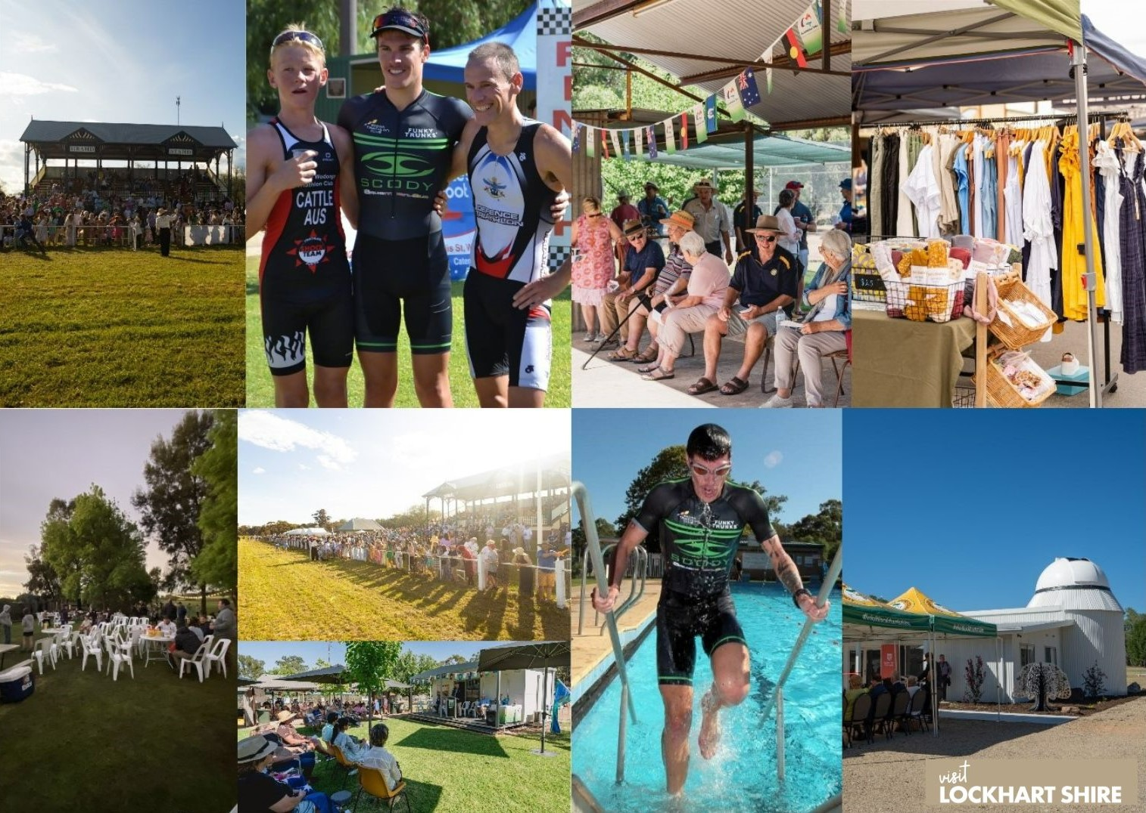

Contact Us

Tourism and Economic Development Officer  Matt Holt | 0419 944 616 mholt@lockhart.nsw.gov.au | Lockhart Shire Council  02 6920 5305  mail@lockhart.nsw.gov.au

Holding an Event on Council Owned or Managed Land

Lockhart Shire offers a range of fantastic parks, open spaces and community halls that are available for you to use and enjoy. We actively encourage local and community events to be held on land owned and managed by Council.

This Kit
The purpose of this application kit is to assist event organisers through the various stages, forms and documentation required by Lockhart Shire Council.

Event organisers are encouraged to read through this information before completing the event application. We also encourage event organisers to contact the events team prior to submitting an event application.

The Application Process
- Read this information pack and make sure you understand everything you need to provide. If things are missing when you submit your application, delays could result in your approvals.

- Consult: We strongly advise that you speak with Council staff before starting your application. Council staff will be able to guide you through the required documentation and provide some additional information and helpful hints.

- Prepare your documentation: This kit outlines what you need to complete when preparing an event application. Make sure you provide as much information as possible when completing the required forms.

- Lodgment: The easiest way to complete your application form is to email the completed documentation through.

To ensure Council has adequate time to review your application and/or request further information, the below timing is requested:
  - Private and Small Event Application Kits – 2 months before event
  - Large Event Application Kits – 3 months before event

Processing your Application
Your application will be assessed and processed once received. Communication will be provided back to event organisers once this process is complete.

Council has a responsibility to ensure that events in streets, parks, garden and halls are properly organised and safely managed. An early application will give Council more time to assist and will give event organisers more time to plan a successful event.

Things to think about when preparing your application
  - Event Location
  - Dates
  - Event Numbers, Lost Children, Crowd Control
  - Insurance
  - Power
  - Sound
  - Lighting
  - Stage, Marquee or Tent Requirements
  - Toilets Facilities
  - Food, Alcohol and Water
  - Waste Management
  - Road Closures
  - Parking / Public Transport
  - Accessibility
  - Security
  - Noise
  - First Aid
  - Signage
  - Weather Conditions

Event Application Form
If you are holding an event in Lockhart Shire please complete an ‘Event Application Form’. The application form provides Council with your event details for review and assessment. A number of documents are required to be attached to your application, these include:
- Event Site Plan
- Program (outline of activities)
- Risk Assessment Plan
- Certificate of Currency Public Liability – listing Council as interested party.

Further information is detailed below on the above forms and documents.

Events may require a one-off Development Application. If your event requires additional Development Consent, a staff member will contact you to advise if this is required.

Event Site Plan and Program
Event organisers are required to provide Council with an event site plan, this is a plan/diagram of the site that details a number of items.

The site plan needs to include the following, if they apply to your event:
  - Stage arrangements – layout and location
  - Lighting
  - Sound, speaker and musician set up
  - Location of marquees, tents and stalls
  - Location of toilets
  - First aid station(s)
  - Security information
  - Parking arrangements
  - Location of attractions and/or amusements
  - Positioning of temporary boundaries or fencing (entry/exit points, ticket box)

Your program should list or outline activities planned for the event.

Risk Assessment and Management
Event safety is very important, and a risk assessment is required for all events as part of the application process.

The reasons for providing a risk assessment are:
  - Duty of Care to provide a safe place for event staff, volunteers, participants and attendees
  - Protecting the event owner and partners
  - Protecting the reputation of the event and Lockhart Shire
  - Complying with insurance requirements

Some examples of hazards include holes in the ground, electrical leads, overcrowding, uneven surfaces, alcohol affected behaviour and water hazards. These hazards can be rectified with simple solutions. By identifying potential risks early, you can develop measures that reduce the chance of an accident or emergency.

Basic Process of Risk Management
Identify
Hazard
Assess Risks
Monitor
Performance
Implement
Controls

Certificate of Currency Public Liability
It is mandatory that the event has comprehensive public liability insurance. Managing a public event includes ensuring the safety of event organisers, staff, volunteers and the public.

Please note that your certificate of currency must note that Council is an interested party.

Council’s public liability insurance cannot be extended to cover external groups or businesses; therefore your organisation will need to produce a Public Liability Certificate of Currency. The event will not be permitted to commence without this in place and provided to Council.

If other organisations are participating in the event, it is important to ensure they also have appropriate public liability. (For example, if your event has food and market stalls attending you will be required to obtain insurance documentation).

If your organisation or community group does not have public liability and you are unable to obtain, you might want to consider collaborating with another community group that has insurance.

Development Application Requirements
A Development Application (DA) is a formal request for permission to carry out proposed development, including the use of premises.

Holding an event may require the lodgment of a development application to Council.

Some events are exempt from development which is determined under the State Environmental Planning Policy 2008 (Exempt and Complying).

If your event requires additional Development Consent, a staff member will contact you to advise if this is required. If you would like to discuss the DA process, please contact Council’s Planning and Environment Team.

Other Information
Noise
Noise at events can be higher than normal. Factors contributing to noise levels can include music, large crowds, vehicles and generators. Remember to factor in the likelihood of high noise levels and manage them to minimise the effect on neighbouring residents. Noise pollution is a source of many complaints to authorities in communities.

Security
Event security may be required. The circumstances under which you may need security include ticketed entry, alcohol service, valuable goods, equipment or vehicles on site.

Food Stalls
To ensure the operation of food stalls is carried out according to adequate Health and Safety requirements, Council’s Safe Food Handling Policy should be referenced.
Inspection of food stalls may be required by Council. Please contact Council’s Planning and Environment section to discuss further.

Event organisers and food stalls are to be made aware of Council’s Safe Food Handling policy. It is the responsibility of event organisers to pass this information on to stall holders.

Alcohol
If you are intending to serve or supply alcohol at your event, visit the below websites for information regarding issues that may affect the service of alcohol and approval requirements.
- www.olgr.nsw.gov.au/liquor_license_apps.asp
- www.onegov.nsw.gov.au/new/categories/liquor-gaming

Promoting your Event
There are a number of methods and channels to market and promote your event. Your research into your markets should help you decide how best to reach attendees. These can include media releases, partnerships, mailing lists, website, social media, word of mouth, TV, radio, and print advertising.

Parking
Parking needs to be carefully managed. Consider the number of cars your event may attract, the lighting in the parking area if the event is after dark, clearly marked signage and traffic controllers.

Accessibility
Assess your venue for accessibility. Event attendees with disabilities need to be able to enter the venue and use all amenities.

Event Evaluation
It’s important to evaluate your event, reviewing your event will enable future improvements and growth. Ways to evaluate your event can include a survey, meetings with major partners and word of mouth.

Event Resources
Council has several free event resources available to use. Please contact us or visit our website.

Required Documentation - Checklist
- Event Application Form
- Event Site Plan
- Program (outline of activities)
- Risk Assessment
- Certificate of Currency Public Liability

Fees and Charges
There is no fee to lodge your event application. Your event may incur a fee if you are required to complete any of the below:
  - Development Application Consent
  - Road Closures
  - Use of Council Staff or Equipment
  - Hire of particular buildings

Event organisers will be notified of any fees and charges after you lodge your event application.

Templates and Documents
A number of templates and documents are included within this kit. If you have any questions or require additional information, please contact the events team. Individual documents are listed on www.lockhart.nsw.gov.au.

Contact Us
Tourism and Economic Development Officer
Matt Holt | 0419 944 616 mholt@lockhart.nsw.gov.au

Event Application Form
Any event on Council owned or managed land must complete this form. Lockhart Shire Council is committed to working with organisations and community groups to hold successful events.

Applicant Details
Name
Organisation or Community Group
Address
Phone |  | Mobile
Email
Website
Facebook |  | Instagram

Event Details
Event Name
Location/Venue
Date(s)
Start Time |  | Finish Time
Set-up Time |  | Pack-up Time
Expected attendance numbers
Wet weather plan
Describe your event
Is the event being held on Council–owned or managed land? □ Yes □ No
Will there be a fee or charge to attend the event? □ Yes □ No
Is the event likely to be an ongoing event? □ Yes □ No
Will your event be open to the public? □ Yes □ No
Will you require the use of Council services or equipment? □ Yes □ No
If yes, please indicate these below:
(Example: Bins, lighting, traffic controllers, equipment) Please note fees may apply.

Insurance
It is mandatory for all event organisers to complete and submit insurance documentation. Copies of the Certificate of Currency for the organisation or community group’s insurance covering the event dates are required. Your certificate of currency must note Council as an interested party and should be at a minimum of $20 million.
Does your event have public liability insurance? □ Yes □ No
Insurances must be provided to you from every person/persons who will be providing a service at your event. (e.g.: market stalls, food vendors, performers).

Risk Assessment
It is mandatory for all event organisers to complete and submit and risk assessment. Event safety is very important and a risk assessment is required for all events as part of the application process.
Attached Risk Assessment □ Yes □ No

Event Specifics
Please indicate if any of the following are relevant to your event:
- 1 Fireworks
- 2 Amusements (e.g.: Jumping castles, petting zoo)
- 3 Consumption of alcohol
- 4 Food and drinks
- 5 Temporary structures
- 6 Market stalls
- 7 Bands, musicians or performers
- 8 Traffic disruption or road closures
- 9 Banners
Please note that third parties involved must have public liability.
- Fireworks
Fireworks require approval from Service NSW as a single event approval. Please visit https://www.service.nsw.gov.au/transaction/apply-fireworks-single-use-licence
Name of pyrotechnic company
Location of fireworks
Attach copies of | - Insurance  - Risk Assessment from company
Has approval been obtained from Service NSW for use of Fireworks? □ Yes □ No
(Please provide a copy of this approval.)
If unable to attach to this application, indicate when they will be available:
- Amusements
List amusements
Copies of public liability and insurance documents are to be provided to you before the event date.
Please note approval under Section 68 of the Local Government Act 1993 is required for certain devices. Please contact Council to discuss further and gain approval.
- Alcohol
Which option applies to your event? □ BYO □ Sold □ Supplied
What type of liquor licence have you applied for?
Has an application been lodged? |  |  | □ Yes □ No
Detail how you will enforce responsible service of alcohol
- Food and Drinks (non-alcoholic)
Please provide details on the type of food and drinks being provided
List food and drink providers
All stall holders have provided a copy of their certificate of currency. □ Yes □ No
Copies of public liability and insurance documents are to be provided before the event date.
Council’s Safe Food Handling Policy is to be provided to food and drink stall holders. This is the responsibility of event organisers.
- Temporary Structures
Please provide details of all temporary structures that will be used at your event. (e.g.: Marquees, tents, stages)
- Market Stalls
Please provide details on the type of markets being provided
List market stalls
Copies of public liability and insurance documents are to be provided before the event date.
All market stalls have provided a copy of their certificate of currency. □ Yes □ No
- Bands, musicians or performers
Please provide details on the type of entertainment being provided
List bands, musicians or performers
All bands, musicians and performers have provided a copy of their certificate of currency. □ Yes □ No
Copies of public liability and insurance documents are to be provided before the event date.
- Traffic disruption/Road closures
Does your event disrupt or impact traffic? Either traffic or pedestrian. □ Yes □ No
Does your event require a road closure? □ Yes □ No
If yes to the above, Submission of a ‘Special Event Transport Management Plan Template’ form and a Traffic Control Plan (TCP) will be required.
Traffic Control Plan
Do you require Council to develop Traffic Control Plan? □ Yes □ No
Will you provide your own Traffic Control Plan? □ Yes □ No
(Traffic Plans must be prepared by person with current accreditation).
Traffic Control
Do you require Council to provide traffic control as per the Traffic Control Plan and accept the responsibility of associated costs? □ Yes □ No
Will you arrange qualified personnel other than Council to provide Traffic Control? □ Yes □ No
Please note. If Council is required to develop and complete your Traffic Control Plan, a fee will be charged (as per Council’s fees and charges).
Please complete ‘Request for Plant Hire/Carry Out Private Contract Work’ Form if required.
- Banners
Are you seeking permission to erect banners on Council poles and/or property? □ Yes □ No
If yes, please describe banner and proposed location.

Required Documentation
Kit 1 - Large Event Application | Kit 2 - Small Event Application | Kit 3 - Private Event Application
- Event Application Form (this form)  - Event Site Plan  - Program  - Risk Assessment  - Certificate of Currency Public Liability Road Closure (If applicable)  - Traffic Management Plan | - Event Application Form (this form)  - Event Site Plan  - Program  - Risk Assessment  - Certificate of Currency Public Liability | - Event Application Form (this form)  - Risk Assessment

Signature
Event Organiser
Name (Print) |  | Date
Signed

Contact Us
Tourism and Economic  Development Officer  Matt Holt | 0419 944 616 mholt@lockhart.nsw.gov.au | Lockhart Shire Council  02 6920 5305  mail@lockhart.nsw.gov.au

Event Risk Assessment
It is mandatory for all event organisers to complete and submit a risk assessment with event applications. If inspection reveals that use of the facility will not be safe, do not proceed until action is taken to ensure the risk has been eliminated.

Event Name |  | Event Location
Assessment completed by |  | Event Coordinator
Signature |  | Reviewed by
 |  | Review date

Please refer to the next page for details regarding Likelihood, Consequence and Rating.

Event Activity  Activity or task involved in event | Hazards/Issues  What could go wrong | Controls to be implemented | Person allocated responsibility | Likelihood | Consequence | Rating

Likelihood
Likelihood | Category | Description
Almost Certain | A | The hazard/issue is expected to occur in most circumstances
Likely | B | The hazard/issue will probably occur in most circumstances
Possible | C | The hazard/issue should occur at some time
Unlikely | D | The hazard/issue could occur at some time
Rare | E | The hazard/issue may occur only in exceptional circumstances

Consequence
Consequence | Category | Example detail Description
Catastrophic | 5 | - Irreversible damage  - Catastrophic financial loss  - Single Death/multiple long term or critical injuries  - National and International concern/exposure
Major | 4 | - Harm requiring restorative work  - Major financial loss  - Single minor disablement/multiple temporary disablement  - State–wide concern/exposure
Moderate | 3 | - Temporary, recoverable service failure  - Residual pollution requiring cleanup work  - High financial loss  - Injury/medical treatment required  - Local community concern
Minor | 2 | - Brief service interruption  - Remote, temporary pollution  - Medium financial loss  - Minor First Aid  - Customer complaint
Insignificant | 1 | - Low financial loss  - Basic First Aid  - Resolved in day-to-day management

Rating
Likelihood  Label | Consequence Label
 | 1 | 2 | 3 | 4 | 5
A | Medium | Medium | High | Very High | Very High
B | Medium | Medium | High | High | Very High
C | Low | Medium | Medium | High | High
D | Low | Low | Medium | Medium | High
E | Low | Low | Medium | Medium | Medium

